**DATA CONTROL LANGUAGE COMMANDS AND TRANSACTION CONTROL COMMANDS**

**EX.NO:3**

**DATE:**

**AIM:**

To create a database using Data Control Commands and Transaction Control Commands tomanage transactions in the database.

**DESCRIPTION:**

**Transaction Control statements**

**Transaction Control Language** (TCL) commands are used to managetransactions in the database. These are used to manage the changes made by DML-statements. It also allows statements to be grouped together into logical transactions.

**Examples of TCL:**

(i) Commit

(ii) Rollback

(iii) Savepoint

**(i)Commit:** Commit command saves all the work done.

**Syntax:** commit;

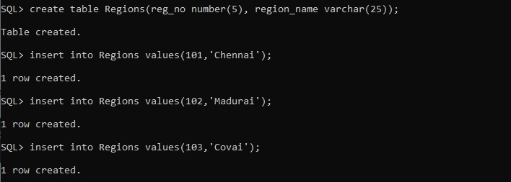

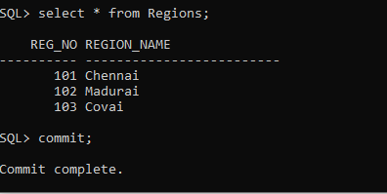

**(ii)Rollback**: Rollback Command restores database to original since the last Commit.

**Syntax:** ROLLBACK TO SAVEPOINT <savepoint_name>;

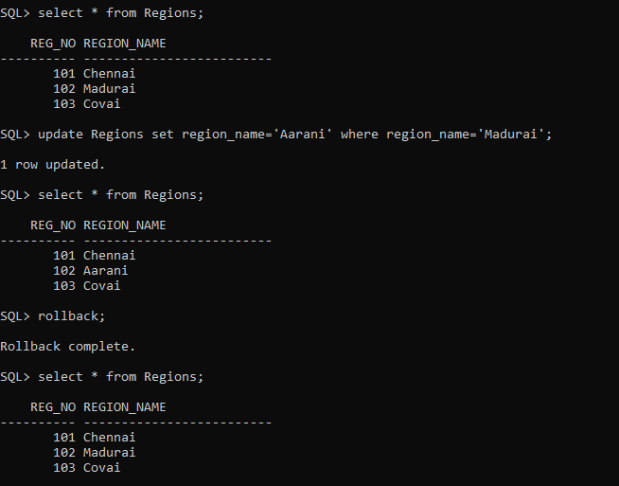

**(iii) Savepoint:**

SAVEPOINT command is used to temporarily save a transaction so that you can rollback to that point whenever required.

In short, using this command we can name the different states of our data in any table and then rollback to that state using the ROLLBACK command whenever required.

**Syntax:**SAVEPOINT <savepoint_name>;

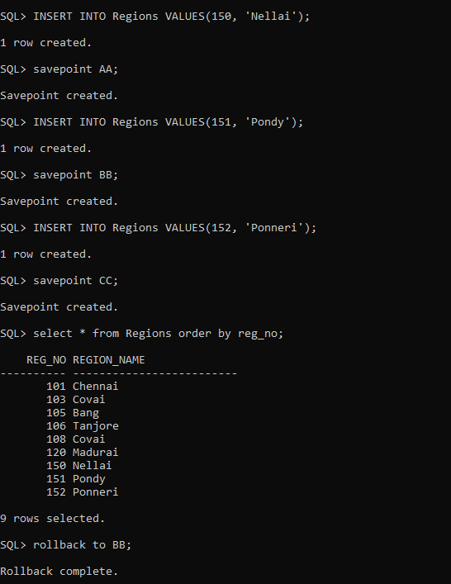

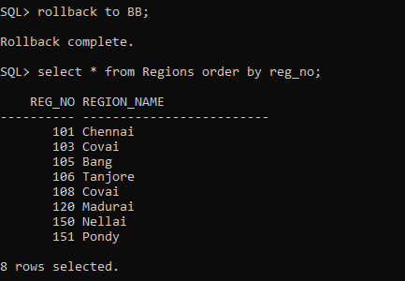

**Data Control Language**

Data Control Language (DCL) is used to control privileges in Database. To perform any operation in the database, such as for creating tables, sequences or views, a user needs privileges. Privileges are of two types,

* **System:** This includes permissions for creating session, table, etc and all types of other system privileges.
* **Object:** This includes permissions for any command or query to perform any operation on the database tables.

In DCL we have two commands,

* **GRANT:** Used to provide any user access privileges or other privileges for the database.
* **REVOKE:** Used to take back permissions from any user.

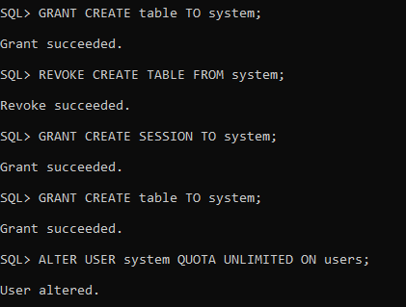

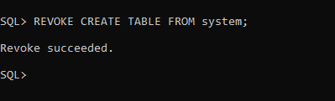

**RESULT:**

Thus the Data Control Language commands and Transaction Control Language commands were executed successfully.